Vinalhaven Land Trust
Founded in 1986, Vinalhaven Land Trust (VLT) offers over 15 miles of well- maintained trails on our preserves. In 2011, we celebrated our 25th anniversary by gaining accreditation from the Land Trust Alliance; only the fourth land trust in Maine to be so recognized. In addition to our role as stewards of these properties, we also offer educational programs and guided walks throughout the year. For more information, visit our kiosk to find maps, schedules of events, and detailed preserve brochures. It’s located in Skoog Park, just 2/1o of a mile west of the ferry terminal along Sands Road. Feel free to enjoy our picnic table overlooking Sands Cove where you can relax with your lunch.

VLT’s work relies on the generosity of our members. For more information on how to support our work, please contact us.

Skoog Park
P.O. Box 268 Vinalhaven, ME 04863
207-863-2543

www.vinalhavenlandtrust.org info@vinalhavenlandtrust.org

Vinalhaven Land Trust promotes the conservation and appreciation of our island's significant plant and wildlife habitat, our water resources, and scenic or traditionally valued spaces in order to preserve the character of the community for generations to come.
Granite Island Preserve
and Story Trail

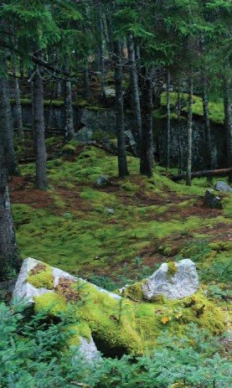

History
This parcel of forested land on the west shore of the Basin is quintessential Vinal- haven, containing everything from Indian relics to traces of granite quarrying opera- tions. In the 1930s when the Booth Bros. & Hurricane Island Granite Company owned this land, the trees were completely cleared to facilitate their quarrying activities. A neighbor, Stanton Strawson, was so upset by the resulting appearance that he made a very modest offer to buy the land, hoping to bring it back to a forest again. His offer was refused, but a month later, the company was going bankrupt and accepted his offer.

Since then, the land has been allowed to grow trees. Moreover, as the forest came back, island residents were allowed to harvest any trees that blew down, and to this day, some Vinalhaven residents still call it "the Strawson woodlot." When VLT acquired the property in 2008, Stanton's son, Fred Strawson, sent us a letter full of his family's memories from their eight decades on this land, along with his hopes that townspeople could continue to harvest these windfalls.

Hikers have two choices at the trail head, both of which take one to the shores of the Basin. The Story Trail, which goes off to the left from the trail head, is a partnership with Vinalhaven Reads. For more informa- tion, please visit our website. The loop trail to the right will take you through tall spruces and firs, where deep blankets of moss and lichens cover the scars left behind by the old stonecutters,with scattered piles of granite pavers that never made it to market.

Natural Resources
In addition to the tranquil shade of the spruce forest, this parcel offers wonderful views looking east across the Basin. Pocket salt marshes and rocky ledges extend all along the water's edge, and as the tide falls new ledges are continually appearing.
There aren't many better locations on the island to sit with binoculars as the day winds down; you can sit in the shade of tall trees, with the Basin dazzling blue and brightly-lit in front of you. Sea ducks, kingfishers, terns, and harbor seals are all common sights here, and a keen eye might spot a raccoon, mink, or river otter - or an eagle perching just above you, taking advantage of the same views for his after- noon hunting.
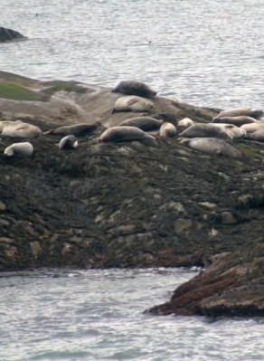

Granite Island Preserve and Story Trail

The Basin

Old Harbor

The
Amphitheater

Story Trail

The Basin

Ferry Terminal

Loop Trail
d

N

W E
Parking Paved Road
Unpaved Road Trail
Building

Kintner Salt Marsh
S

0 500 1000 feet

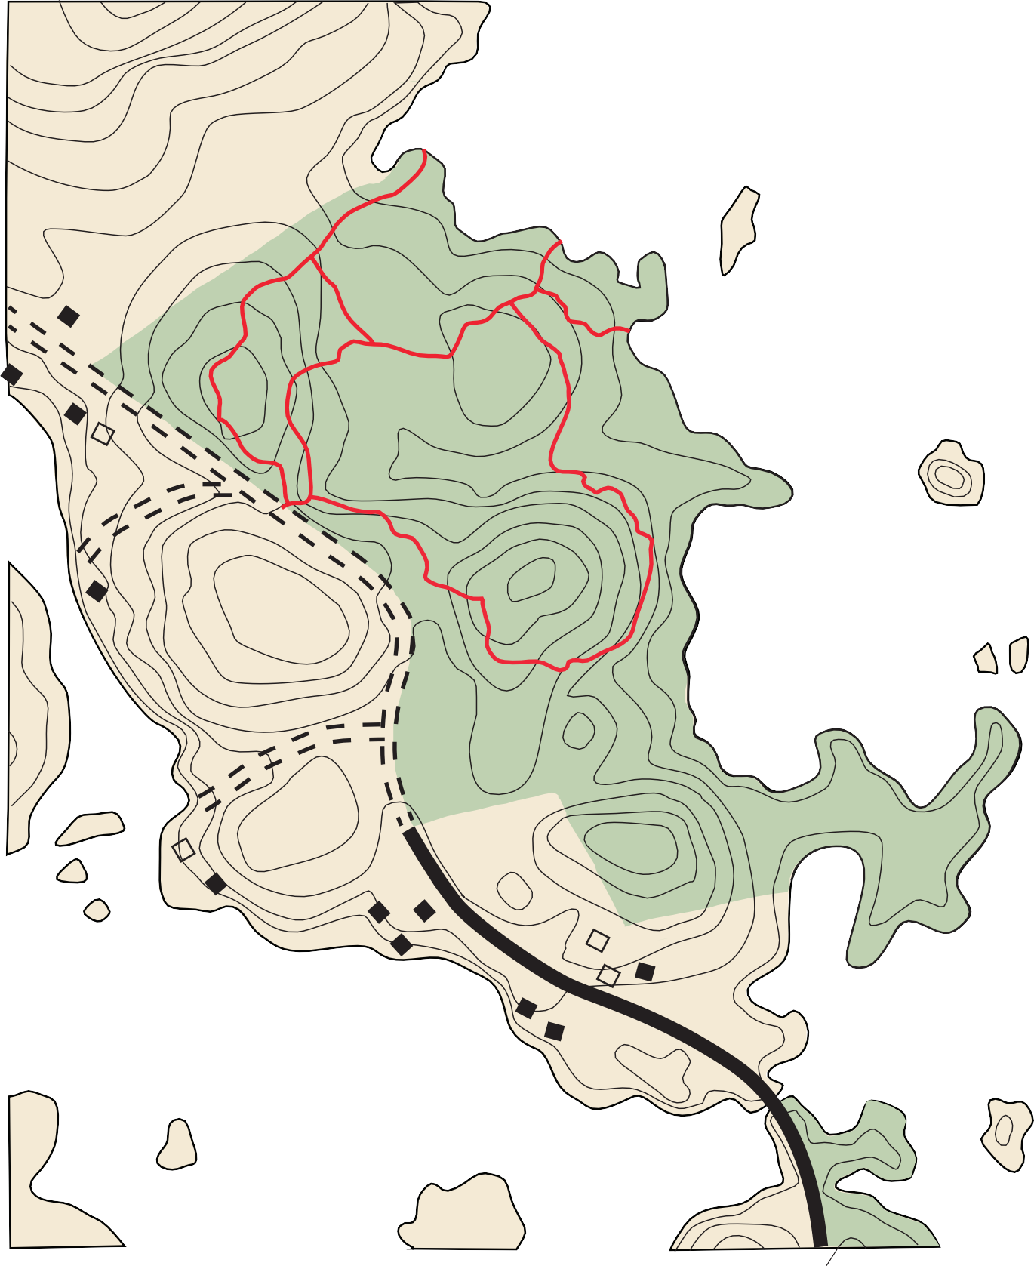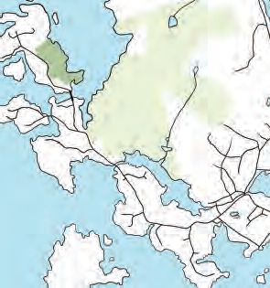Size: 42 acres
Trails: The Loop Trail is about a mile long and starts and ends at the trailhead parking lot, with three short spur trails taking hikers to scenic overlooks (two with benches) on the shore. The Story Trail, featuring a book for young readers or work from Students at the Vinalhaven School is 0.2 miles.
Features: The whole spectrum of Vinalhaven granite, from uncut ledges to abandoned paving stones, can be seen as you walk around this preserve. Hikers here will enjoy trailside moss gardens, great views across the Basin, and abundant opportunities for wildlife observation, including large groups of harbor seals hauling out on tidal ledges.

Be Aware: The lush growth of mosses and lichens on the granite ledges and forest floor cannot tolerate foot traffic; please stay on the trail. At the shore, please stay on ledges and rocks to avoid trampling the salt marsh vegetation. Please respect our neighbors' privacy and be aware of the preserve

boundaries. If you walk too far along the shore, you'll be in someone’s yard.

Directions: From the ferry, turn left and go
0.4 miles on Sands Road, then left again on Old Harbor Road. Proceed for about two miles, which will take you through the village at Vinalhaven's "Old Harbor" and then across the bridge at the Lower Basin Falls. The
gravel parking lot and trailhead will be on your right.

